REDUX TOOLKIT
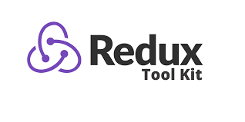
Redux Toolkit or RTK is an node package that simplify the development by providing utility functions. It is made to simplify the creation of redux store and provide easy state management. It can be easily installed using simple npm commands.
-Before the introduction of the Redux toolkit state management was complex in simple redux.


Problems solved by Redux Toolkit (RTK) in Redux
Redux Toolkit was created to solve these three common problems that we face in Redux.
- Too much code to configure the store.
- Writing too much boilerplate code to dispatch actions and store the data in the reducer.
- Extra packages like Redux-Thunk and Redux-Saga for doing asynchronous actions.

HISTORY REDUX TOOLKIT

History of Redux Toolkit (RTK)
1. The Early Redux Era
- Redux was introduced in 2015 by Dan Abramov and Andrew Clark as a state management library for JavaScript applications.
- Early Redux had a steep learning curve, requiring developers to manually configure:
  - Actions
  - Reducers
  - Middleware
  - Boilerplate Code for combining reducers and creating stores.
Developers often complained about:
- The verbosity of Redux code.
- The repetitive patterns and setup steps.
- Confusion over best practices.

2. Challenges Leading to Redux Toolkit
As Redux adoption grew, common challenges emerged:
- Too much boilerplate: Many lines of code just to set up simple features.
- Configuration complexity: Setting up middleware like redux-thunk or redux-saga required extra steps.
- Immutability issues: Writing reducers often involved deeply nested object/array structures, making updates cumbersome.
- Confusion over patterns: New developers struggled to adopt the best Redux practices due to lack of standardization.
The Redux team realized that many of these challenges could be mitigated by providing an official abstraction layer.

3. Introduction of Redux Toolkit
- Redux Toolkit was first released in October 2019 as the official opinionated solution for Redux development.
- It aimed to simplify Redux setup and encourage best practices.
Goals of Redux Toolkit:
- Reduce Boilerplate: Combine actions, reducers, and store setup in a concise way.
- Promote Best Practices: Encourage the use of patterns like immutable updates and centralized state management.
- Simplify Asynchronous Logic: Provide easy-to-use tools like createAsyncThunk for handling side effects (e.g., API calls).
- Improve Developer Experience: Enable rapid prototyping while maintaining scalability.

4. Key Features Introduced
- configureStore: Simplified store creation with built-in middleware.
- createSlice: Combines action creators and reducers in one step.
- createAsyncThunk: A built-in utility for handling asynchronous actions like API calls.
- Built-in Immer Library: Allows you to write reducers with "mutating" syntax, while actually enforcing immutability.
- TypeScript Support: Improved typing utilities for better TypeScript integration.

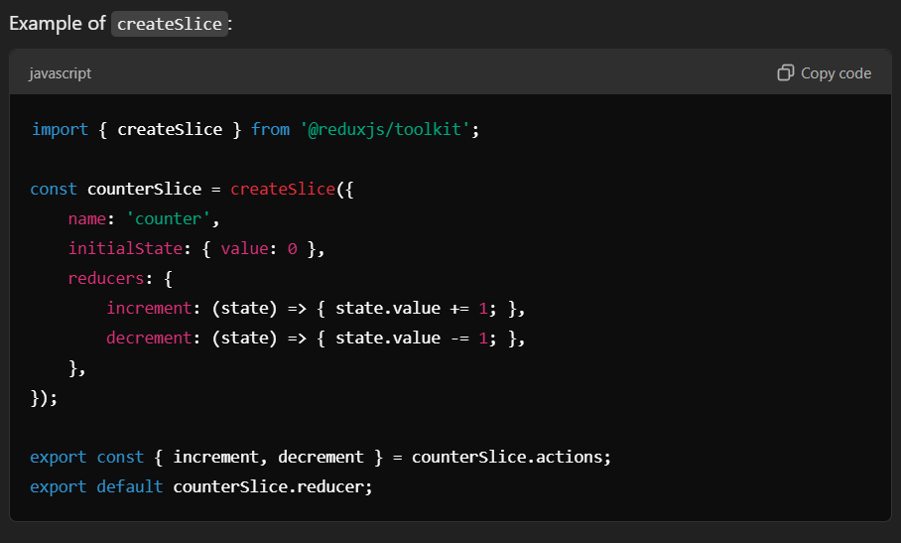
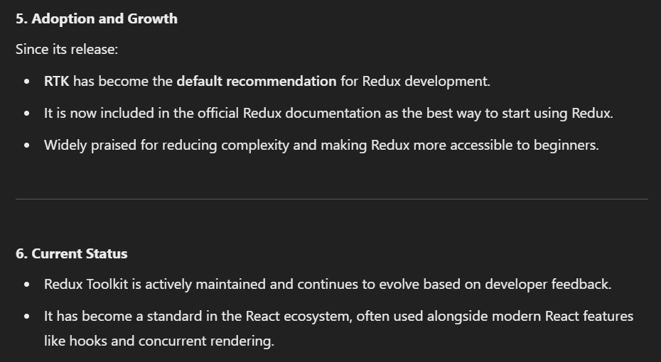

WHAT IS REDUX TOOLKIT

-Redux Toolkit (RTK) is the official, recommended way to write Redux logic. It simplifies the setup and usage of Redux, making it more developer-friendly and less boilerplate-heavy. RTK was introduced to address common complaints about Redux, such as verbosity and complexity.
Key Features of Redux Toolkit:
- Simplified Store Configuration:
  - RTK provides a configureStore method, which automatically sets up the Redux store with good defaults (e.g., middleware like redux-thunk).
- Slices for State Logic:
  - RTK introduces the concept of slices. A slice combines actions and reducers into a single file for better organization.
- Built-in Middleware:
  - Automatically includes middleware like redux-thunk for handling asynchronous logic.
  - Adds development tools such as redux-devtools for easier debugging.
- Immer Integration:
  - RTK uses Immer under the hood, allowing you to write "mutative" logic in reducers while ensuring immutability in the state.
- Redux Thunk Simplification:
  - Supports writing asynchronous logic with minimal setup and less boilerplate.
- Better Developer Experience:
  - Comes with tools and utilities that reduce repetitive tasks, improve code readability, and encourage best practices.

INSTALLATION REDUX TOOLKIT

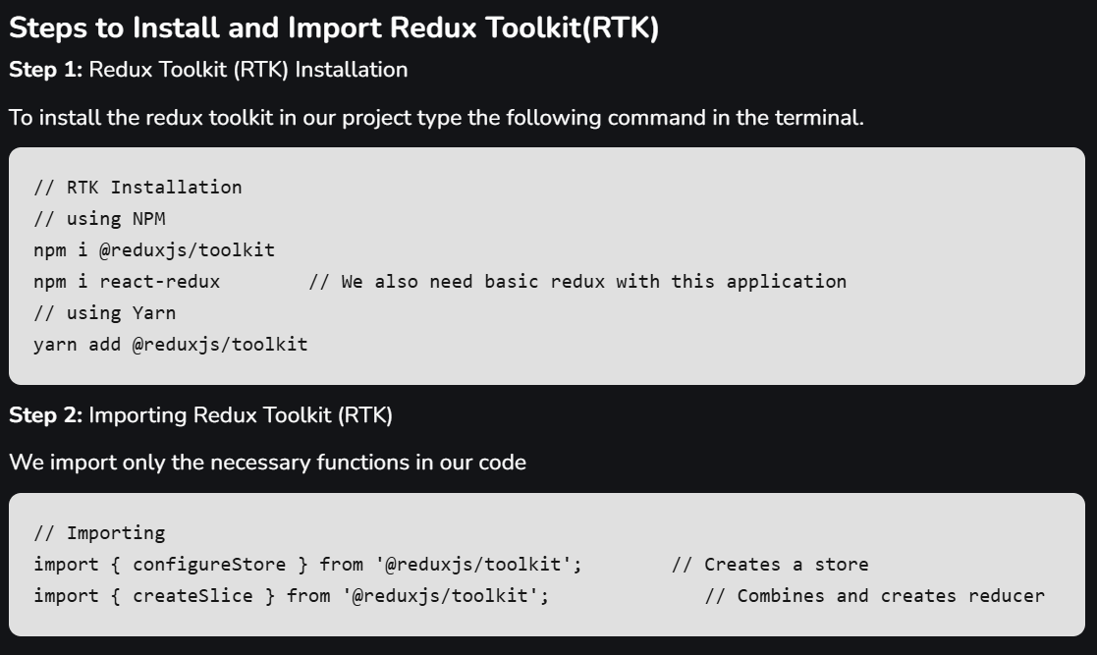

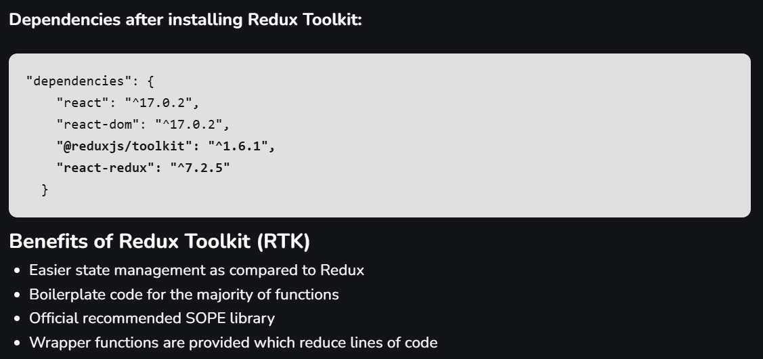

OR

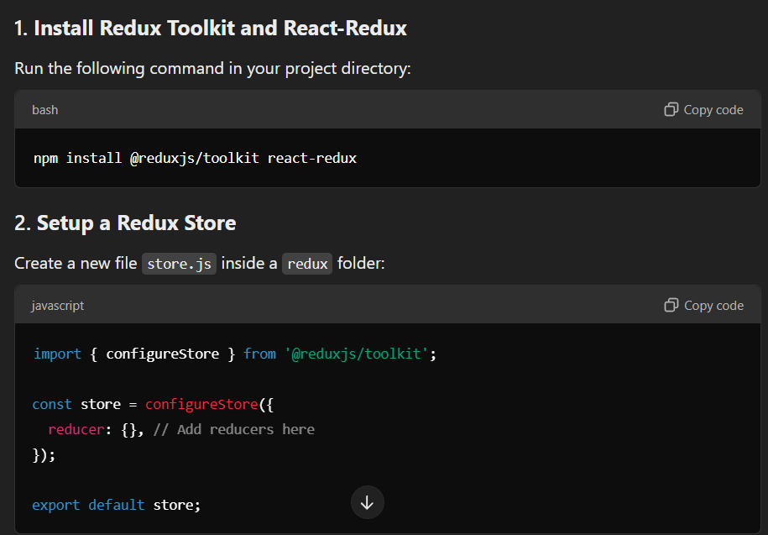
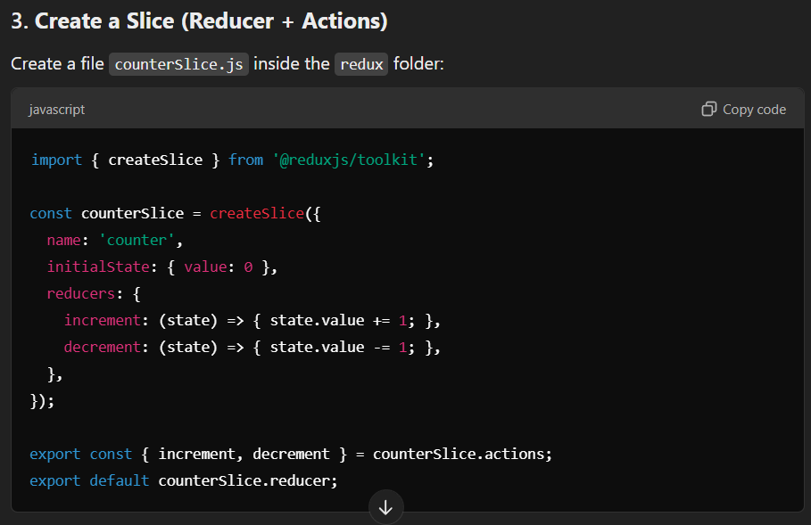
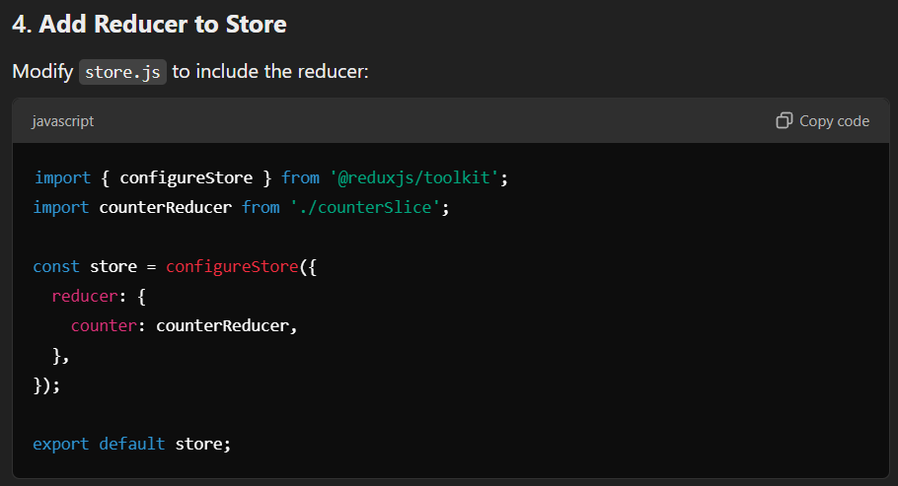
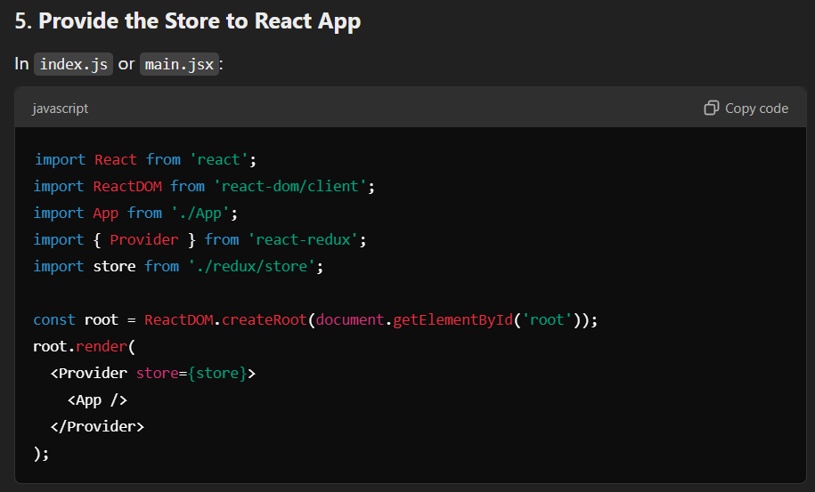
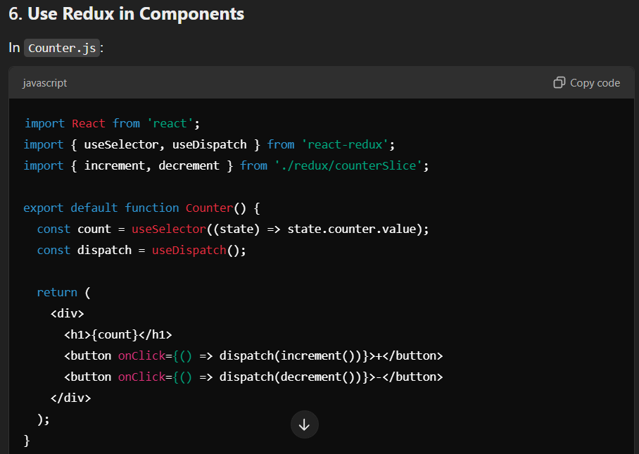

Difference between Redux and Redux Toolkit
React Redux | Redux Toolkit (RTK)
Redux often required writing a significant amount of boilerplate code, such as action creators, reducers, and store setup. | Redux Toolkit is designed to minimize boilerplate code. It includes utilities like createSlice for reducers and configureStore for store configuration, reducing the amount of manual setup required.
Reducers are typically created using a switch statement, handling various action types explicitly. | With createSlice from Redux Toolkit, reducers can be defined more concisely using a “slice” of the state and auto-generated action creators.
Utility libraries like Object.assign or the spread operator are required to ensure immutability | It encourages immutability by providing utility functions like immer internally, allowing more straightforward state updates within reducers.
Setting up the Redux store involves configuring middleware, combining reducers, and applying additional enhancements. | configureStore from Redux Toolkit simplifies store configuration by integrating commonly used middleware and providing a more streamlined setup.
Handling asynchronous actions requires additional middleware, like redux-thunk or redux-saga. | createAsyncThunk is included in Redux Toolkit which simplify the process of managing asynchronous actions within the Redux store.
It may have a steeper learning curve due to the amount of boilerplate code and manual configuration. | It is designed to improve developer experience by reducing boilerplate, making it more accessible and efficient, especially for beginners.

WHY NEED REDUX / REDUX TOOLKIT?

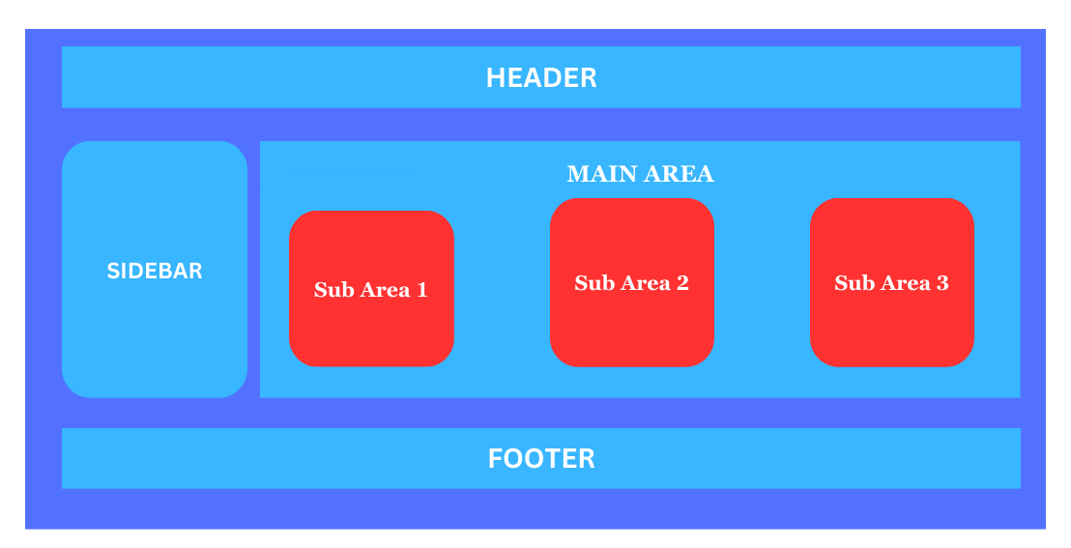
-In above diagram if you want to send data from Sub Area2 to SIDEBAR you have following options.
1]Sub Area2 Main Area ROOT Component SIDEBAR
-First You have send data from Sub Area2 to Main Area then Main Area to ROOT Component and again Root Component To SIDEBAR.
2]Context API (Manages Small Data)
-The Context API manages the small data to handle the large data it make complicated.
-Again there is issue in the Context If you call the REST API in its you have manages separately.
-No there is just minimum component so imagine there is 100+ or 1000+ component are there transferring the data from one component to another component make it difficult.
-So Solving this issue usingb REDUX / REDUX TOOLKIT it make it easier.
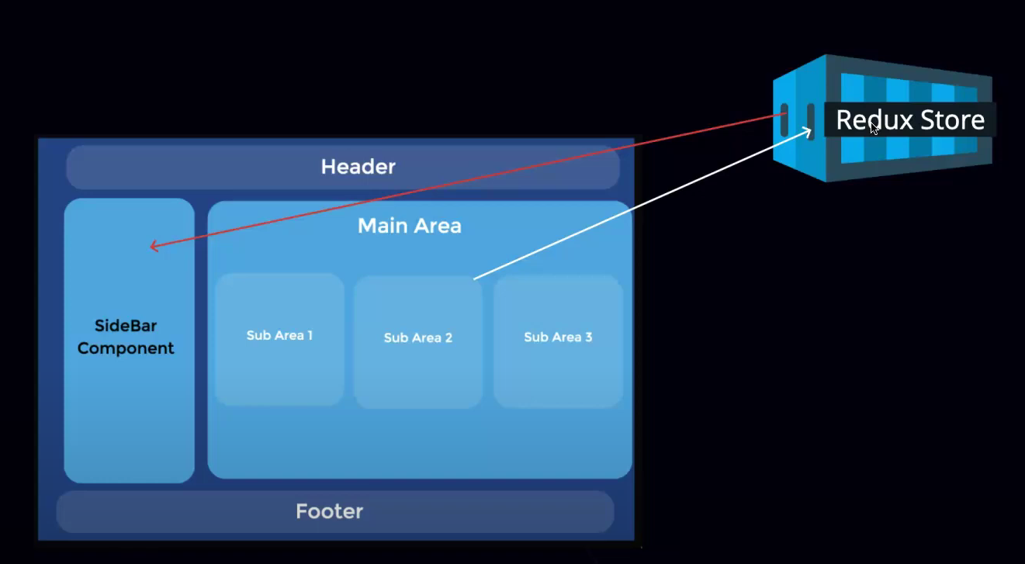
-Here Are the Special Store available to store the data name Redux Store.
-Using Redux Store we can directly Send the data to the SIDEBAR Component or any other component.
-So we can directly access the data from Redux Store.

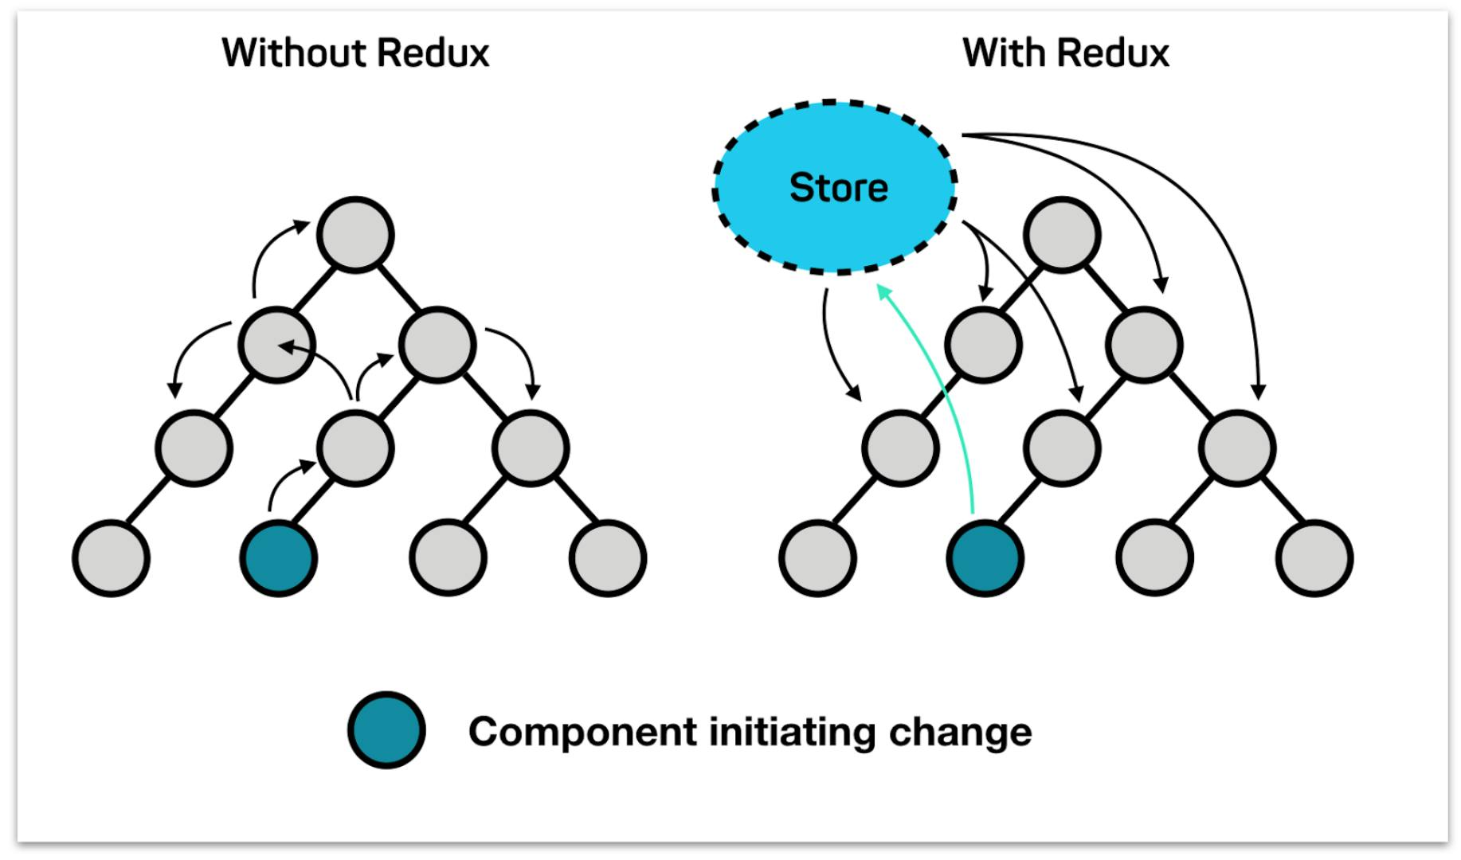

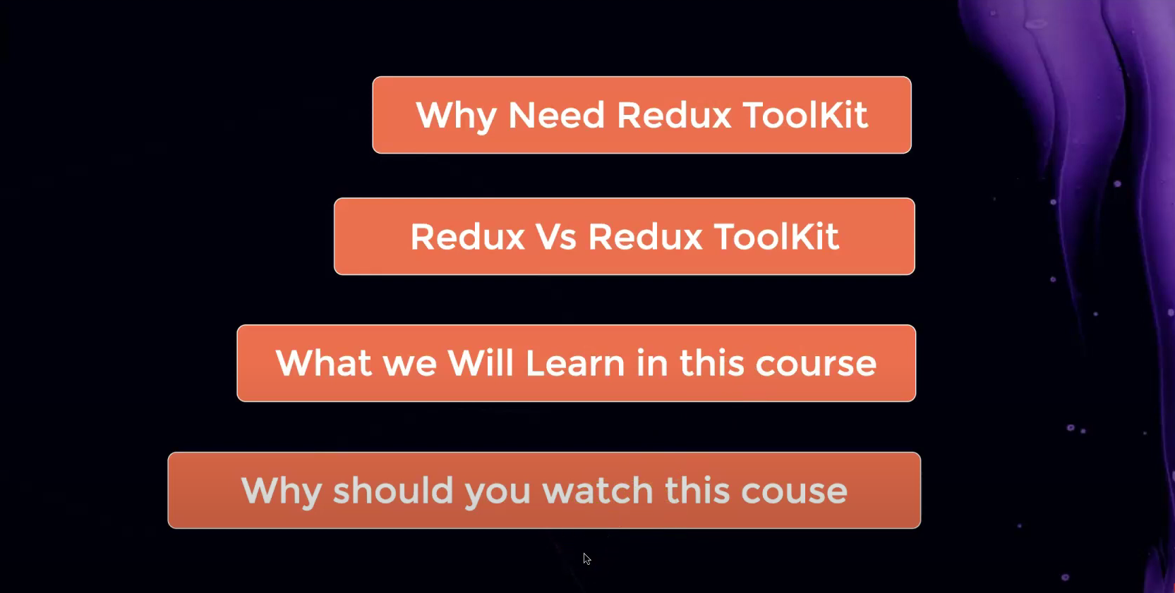

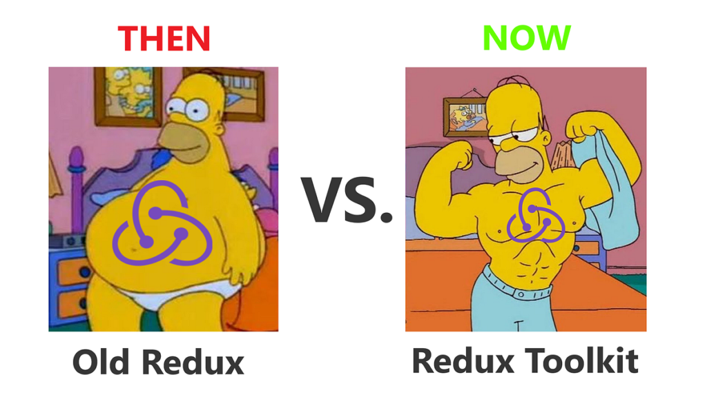

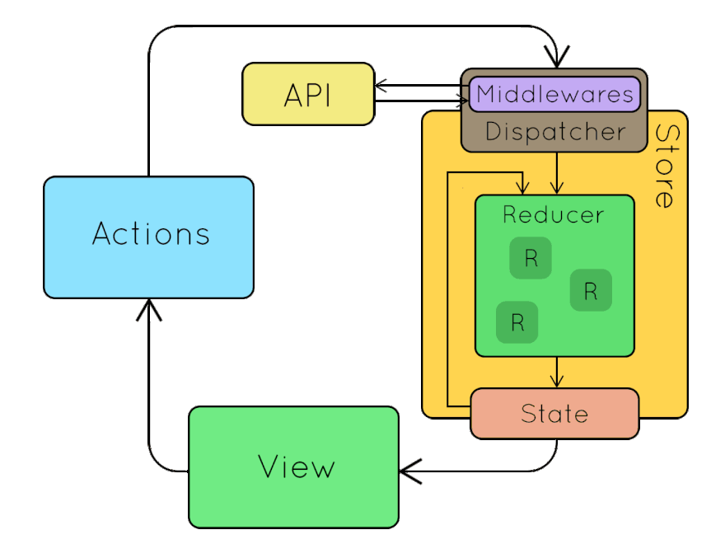
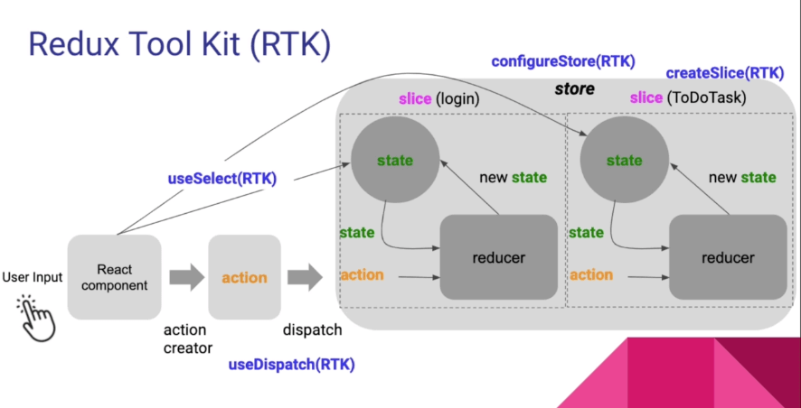
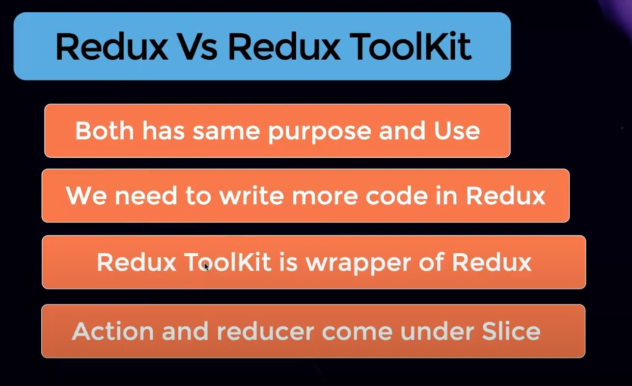
-The developers of Redux and Redux Toolkit are same both product are the same but thing is that Redux-Toolkit is the enhanced version of Redux.
-In Redux – Toolkit they added more features.
-In Redux we have to write the more code as compare to Redux – Toolkit.
-In Redux we have created the more files and we need to install more libraries.
-So writing the code in Redux is complex.
-In Redux – Toolkit we does not need to write the more code and no need to create the more files.

